Reduction Intermediate Spreadsheet (Version 2.6) User Guide
Mark Blackford
March 15th, 2016

This Excel spreadsheet is based on the Citizen Sky Intermediate Spreadsheet (CSIS, http://www.citizensky.org/content/calibration-intermediate ) from the epsilon Aurigae campaign.

R-I V2.6 converts DSLR instrumental magnitudes into transformed and extinction corrected standard magnitudes using an ensemble of 6 Comparison stars. Instrumental magnitudes from all three color channels can be processed. Kloppenborg et al. (JAAVSO, 40, 815, 2012) describes the procedure in detail.

R-I V2.6 calculates the average magnitude from up to 20 observations closely spaced in time. Feel free to modify the spreadsheet for more observations if necessary. It is not intended for time series observations.

There are multiple worksheets (Data, Calculations, Conversions and several example data sheets) which are divided into sections for clarity. This User Guide describes each of the spreadsheet sections, explains data entry and shows how to interpret results.

NOTE: Blue cells (e.g. Cell B2 in Data worksheet) indicate where the user must provide input data. Do not delete or alter any other cells.

Users are encouraged to explore the contents of calculation cells; however, they are not locked so can be accidentally altered. It is recommended that a copy of the original spreadsheet be kept as a backup.

1. Data Worksheet Sections

Observation Information Section
Enter the observer name and observatory latitude and longitude in the blue cells. To determine your latitude and longitude you can use a GPS device or Google Maps (center your observation site in the map and click the link button. The latitude and longitude are encoded in the URL beginning with “ll=”. The Mt. Evans observatory has ll=39.586963,-105.641012 so the latitude is 39.586963, and the longitude is -105.641012)
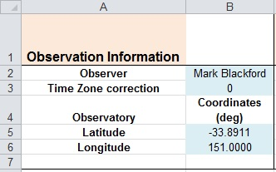

Time Zone Correction is required if reported observation times are offset from the correct time. Set to zero if observation time is accurate.
Star Calibration Data Section
Enter identifier for the variable, check and comparison stars, RA and Dec (in decimal degrees), catalogue magnitudes, (B-V) and (V-R) colour indices in the blue cells. If (V-R) catalog values are not available leave Cells D7:K7 empty. The spreadsheet can still be used for V and B magnitudes but not R magnitudes.

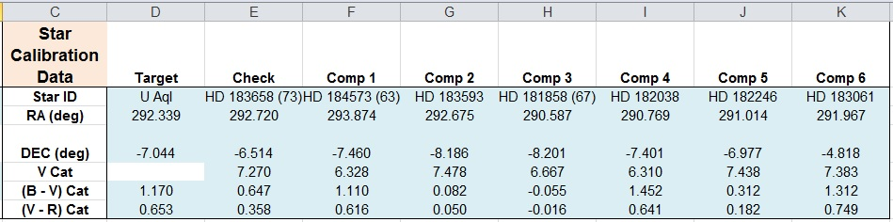

Instrumental Magnitudes Section
Enter Julian date and instrumental magnitudes (IMs) in the blue cells. Blue channel IMs in the first section, then Green channel IMs followed by red channel IMs in the last section.

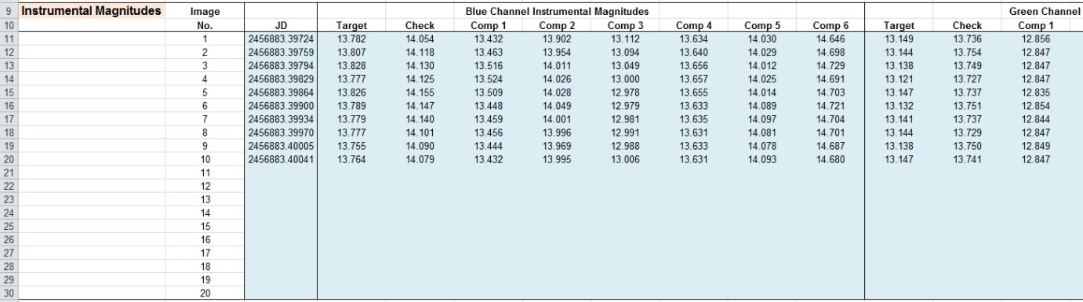

2. Calculations Worksheet Sections

Plot Section (top of sheet)

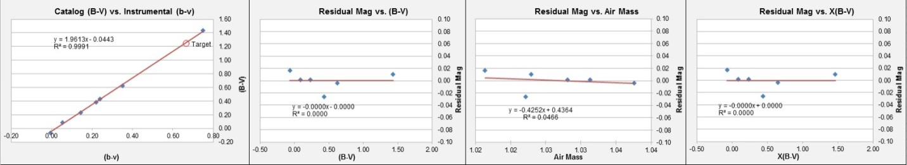

The first graph plots catalog (B-V) color index of the target, check and comparison stars as a function of instrumental (b-v) color index. This requires both blue and green channel instrumental magnitudes in the Data worksheet. Ideally all of the stars would fall on a straight line. A significant offset of a point indicates a problem with the catalog (B-V) value, contamination of the IMs by a nearby star, emission/ absorption lines in the stars’ spectrum or possibly the wrong star having been measured.

The other three graphs plot the comparison star residual (Catalog magnitude – measured magnitude) as a function of Catalog (B-V) color index, Air mass and Air mass times (B-V), respectively. These give a visual indication of any outlier data point that would skew the results.

Observation Information and Star Calibration Data Sections
No user input, information is sourced from Data worksheet.

Target (B-V) Section

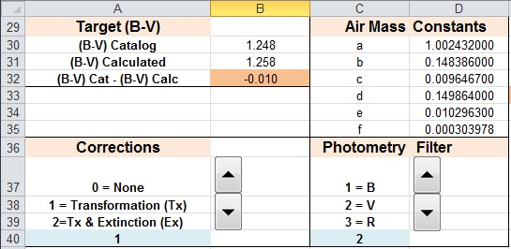

Compares Catalog and calculated (B-V) values for the target star. Cell B32 should be close to zero. This requires both blue and green channel instrumental magnitudes in Data worksheet.

Air Mass Constants Section
Constants used to calculate air mass of stars.

Corrections Section
Use the up/down arrows to select which correction option is to be applied.
“None” calculates standardized magnitudes with no transformation or extinction corrections.
“Transformation (Tx)” calculates standardized magnitudes with transformation applied.
“Tx & Extinction (Ex)” calculates standardized magnitudes with transformation and extinction corrections applied.

Photometry Filter Section
Use the up/down arrows to select which filter magnitudes will be displayed.

Regression Calculations Section

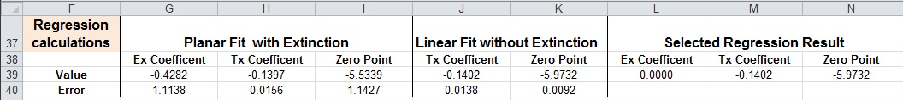

Transformation (Tx) and extinction (Ex) coefficients are calculated using least squares regression of instrumental magnitudes, air mass and catalogue V and B-V values of the comparison stars. The user should check that cells G33:N33 show realistic air mass values.
Quality Check Section

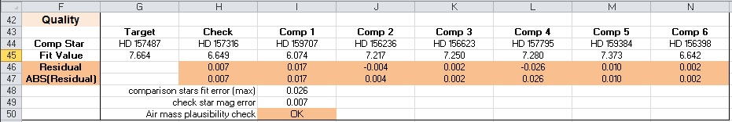

This section helps the user to check the quality of their data and analysis.

Fit Value is the magnitude of each star as determined by the regression calculation.
Residual is the difference between catalogue magnitude and the Fit Value for each star. Residuals nearer to zero are better.
ABS(Residual) is the absolute value of the residual, smaller values are better.
Comparison stars fit error (max) is the largest ABS(Residual) of all the comparison stars.
Check star mag error is the difference between the catalog magnitude and calculated magnitude of the check star. Smaller check star error is better.
Air mass plausibility check is “OK” if the calculated air mass of all measured stars is within the range 1 to 4, if not then “ERROR” is indicated. “N/A” is displayed when extinction correction is turned off in the Corrections Section.

Average Image Data Section

This section calculates the average instrumental magnitudes from the Individual Image Data section, and then calculates standardized magnitudes of the target and check stars. These will be untransformed, transformed or transformed with extinction corrected depending on the value of Cell A40. The value of Cell C40 determines whether B, V or R magnitudes are calculated.

The check star residual (V Cat – V Mag) is also calculated.

Individual Image Data Section

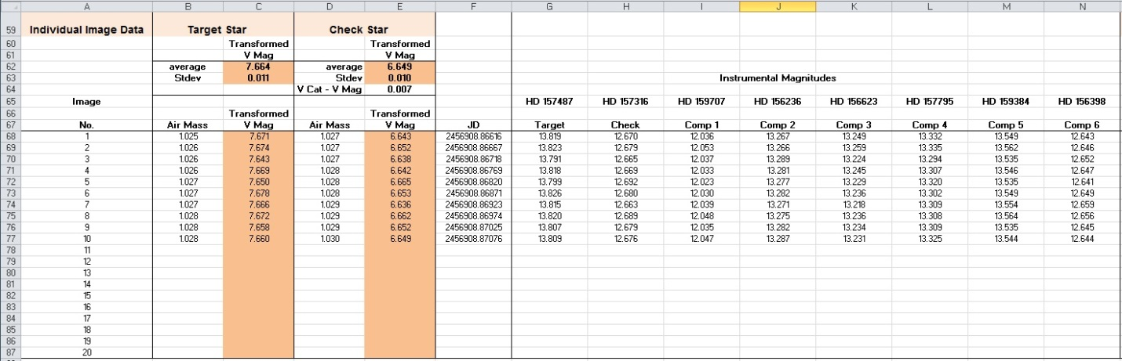

This section calculates the instrumental magnitudes then calculates standardized magnitudes of the target and check stars for each image. These will be untransformed, transformed or transformed with extinction correction depending on the value of Cell A40. The value of Cell C40 determines whether B, V or R magnitudes are calculated.

The check star residual (V Cat – V Mag) is also calculated.

The average magnitude shown in Cell C62 can be reported to AAVSO using WebObs as explained in the AAVSO DSLR Observing Manual. Use the Stdev value in Cell C63 as the measurement error.

Helper Table Sections
These sections perform intermediate calculation steps.

3. Conversions Worksheet Section

The Calculations worksheet requires decimal RA and Declination coordinates for the stars and Julian dates for the observations. The Conversions worksheet provides a convenient way to convert between the normal RA and Declination system and decimal coordinates.

There are also tools for conversion of local time to/from UT and JD.

Convert RA and Dec to decimal coordinates Section
Calculates decimal RA and Dec coordinates from standard RA and Dec coordinates entered in the blues cells.

Convert decimal coordinates to RA and Dec Section
Calculates RA and Dec coordinates from decimal coordinates entered in the blues cells.

Convert Local Time to UT and JD Section
Calculates UT and JD from local time and time zone correction entered in the blue cells. The user must adjust time zone value to account for Daylight Savings.

Convert JD to UT and Local Time Section
Calculates UT and local time from JD and time zone correction entered in the blue cells. The user must adjust time zone value to account for Daylight Savings.

4. U Aql and E7 Region Worksheets

These worksheets are exactly the same as the Data worksheet but with example data for the classical Cepheid (DCEP) star U Aql and the E7 Region standard star field. These are provided to show how your data should be formatted and to act as test data to learn how to use the R-I V 2.6 spreadsheet for analysis of observations.

Data in these worksheets is high quality and give excellent results because long exposures were possible so signal to noise of the star images is very good. Catalog values for the comparison and check stars are also good. This is not always the case, possibly due to emission or absorption features in their spectra that make them unsuitable for DSLR transformation calibration.

5. U Aql Example

This data is from a set of 10 RAW images (.CR2 extension) recorded on a Canon 1100D DSLR through a 200mm f2.8 lens. The camera was on a tracking mount which allowed 20 second exposures with no trailing of star images. Canon EOS Utility software was used to control the camera so Local time was recorded in the metadata of each image. Therefore it was necessary to enter a time zone correction of 10 hrs in Cell B3.

MaxIm DL was used for image calibration and measurement of instrumental magnitudes.

Copy the entire U Aql example worksheet and paste into the Data worksheet. Select the Calculations worksheet and set Cell A40 to 0 (no corrections) and Cell C40 to 2 (V filter). The first plot shows the (B-V) color index as a function of instrumental (b-v) color index for the 6 comparison stars and one check star (blue diamonds). These are tightly clustered around the line of best fit, which is good.

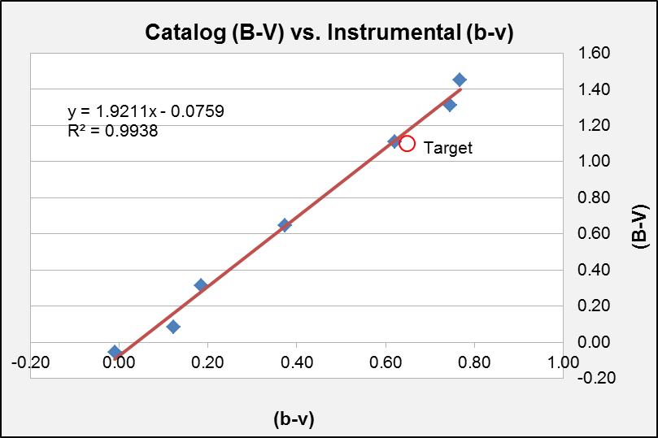

The red circle symbol of the target star (U Aql) is slightly below the line of best fit indicating catalog (B-V) is not quite correct. Cell B32 shows the difference between catalog (B-V) and calculated (B-V) is -0.070. U Aql changes color slightly during its 7 day pulsation cycle so it isn’t surprising that the catalog (B-V) value of 1.10 from SIMBAD wasn’t exactly correct at the time these images were recorded.

We need to change Cell D6 in the Data worksheet to the correct (B-V) value of 1.170 at that point in time. Cell B32 in Calculations worksheet then changes to 0.000 and the red circle on the plot now sits on the line of best fit.

When Cell A40 = 0 (no corrections) the three residual plots do not show meaningful information so ignore them for now.

Standardised magnitude for the target and check stars are shown in Cell C62 and E62, respectively. These are the average of measurements from the ten individual images (listed below starting at line 68). Standard deviation of the ten measurements is listed in Cells C63 and E63. Report these values as the measurement error.

Now change Cell A40 to 1 to calculated transformed magnitudes. Check star value changes only a few millimags but the target star transformed magnitude is about 60 millimags brighter than the standardised magnitude. This is because U Aql is significantly redder than the check star so the transformation correction is larger.

The three residual plots now show meaningful information. Residuals for V are significantly better than for B and R because there are two green channels which are more sensitive than the single B and R channels. Therefore measurement scatter is larger in B and R compared with V.

Now change Cell C40 to 1 (B) and 3 (R) to see the calculated magnitudes in these photometric filter bands. Notice that the standard deviation values are significantly larger for B and R compared with V. These could be improved by using longer exposures but at the risk of saturating the green channels.

6. E7 Region Example

This data is from a set of 10 FITS images (.fit extension) recorded on a Canon 1100D DSLR through a 200mm f2.8 lens. The camera was on a tracking mount which allowed 35 second exposures with no trailing of star images. MaxIm DL software was used to control the camera so Universal Time was recorded in the FITS header of each image. Therefore it was not necessary to enter a time zone correction in Cell B3.

MaxIm DL was used for image calibration and measurement of instrumental magnitudes.

Copy the entire E7 Region example worksheet and paste into the Data worksheet. Select the Calculations worksheet and set Cell A40 to 0 (no corrections) and Cell C40 to 2 (V filter). The first plot shows the (B-V) color index as a function of instrumental (b-v) color index for the 6 comparison stars and one check star (blue diamonds). These are tightly clustered around the line of best fit, which is good.

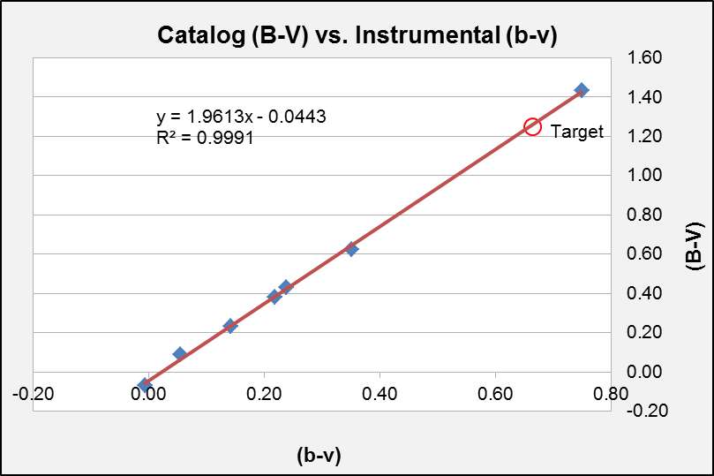

The red circle symbol of the target star (HD 157487) is also very close to the line of best fit indicating catalog (B-V) agrees well with the calculated (B-V) value. Cell B32 shows the difference between catalog (B-V) and calculated (B-V) is -0.010 which is within measurement error.

HD 157487 is a non-variable standard star with very well determined BVR magnitudes so we should not change Cell D6 in the Data worksheet.

Select different correction options (Cell A40) and filters (Cell D40) to see how they affect calculate magnitudes. You should see that extinction correction makes very little difference for the E7 Region and U Aql datasets. This is because both sets of images were recorded when the target was close to culmination so differential air mass across the field of view was very small. Cell E33 shows the maximum differential air mass between the measured stars is only 0.037 for U Aql and 0.021 for the E7 Region.

I need to collect another sample dataset with wider field of view and larger differential air mass to illustrate how effective extinction correction can be.

Now that you’ve experimented with the sample data try reducing your own DSLR measurements. Remember to follow the data entry format of the examples. Good luck.

